**IS 2900 – Project on IT Applications**

**Final Project Proposal**



Department of Interdisciplinary Studies

Faculty of Information Technology

University of Moratuwa

2022

|  |  |  |
| --- | --- | --- |
| **Group Name** | Dominators | |
| **Project Name** | Cloud-Based Bus pass System | |
| **Client’s name and address** | Virtusa Pvt.Ltd  No.752, Dr. Danister de Silva Mw,  Colombo 09. | |
| **Group Members** | Index No | Name |
| 205119P | Wijethilaka W.G.D.C.D. |
| 185067A | Rosni H.F. |
| 205063L | Madhushika D.S. |
| 205016X | De Silva R.M.M. |
| 205091U | Sadhoon M.I.A. |
| **Supervisors’ names** | 1. Dr. S.C. Premaratne   2. Mrs. M.B. Mufitha | |

**1. Introduction**

The cloud-based Bus Pass Management System is a real-time project that will benefit passengers as well as the owners of the buses, who are dissatisfied with the existing manual bus pass system. It allows passengers to travel more easily by scanning the ticket QR code with their smart devices. Passengers can purchase bus tickets beforehand for a week at any time online 24 hours a day. Seven days a week, which eliminates the problem of forgotten or stolen bus tickets.

This system reduces the time wastage that happens to the passengers during a bus journey and provides ease of money transactions. It gives a live update as well about the relevant bus and the bus route to the passengers and confirms the safety of the journey too through the system.

**2. Problem in brief**

Nowadays, due to the scarcity of fuel, there is a huge tendency of using public transportation systems rather than personal vehicles.

Traveling by bus is the easiest and most affordable way of all public transportation methods but there are so many difficulties in picking a bus like unawareness of the Timetables of certain days, the inability to pick a seat, unawareness of the bus fares because of the rising prices…etc. In addition, sometimes when passengers come on time at the bus halt, they cannot check the seat availability of the bus they are waiting for and the location where it is too.

When we discuss children, they cannot take a lot of money with them because it is unsafe these days. But there is not a good option to transfer the bus fare from the parents’ account too. Apart from that when the children travel alone, there is no way to make parents aware of whether children got in and out of the bus at a certain time and a location.

In addition, from the administration perspective, there is a huge manual process of registering with much paperwork that is time-consuming.

When we travel by bus, there are lots of emergency cases like bus breakdowns, traffic and so many situations that we have to face. But there is not even a manual method of booking a bus seat before the journey.

A smart method is required to book a seat on a bus and enjoy the journey.

**3. Aim and Objectives**

Aim: Providing safe, dependable, affordable, cost-effective, and efficient service to passengers, easy registration, and a better profit to the bus owner, and easy administration and managing space for the administration.

Objectives:

* Allowing users to book their seats conveniently and facilitating 24/7 services to passengers helping to avoid fraud during transactions and giving safety.
* Providing an effective payment method with safeguard infrastructure to users.
* To provide Inquiries sections for passengers for users to put forward their problems
* Facilitating the location tracking feature
* Easing the ticketing process and seat distribution to the conductors and notifying the user about seat availability.
* Reducing the paperwork (manual bookkeeping) and reducing the staff, which reduces the expenses.
* Managing schedule effectively and avoiding bus delays and managing emergencies
* ability to manage many buses concurrently easily keeping a database and reselling tickets

**4. Proposed Solution**

There are 5 primary actors as Admin, Conductor, Bus Owners, Timekeeper, and Passengers with different levels of permissions.

Passengers first have to sign up through their Google accounts or Facebook accounts and create an account entering their name, address, and NIC after the verification to ensure the security of the system. Then he can log in to the system and check the availability of the buses, and seats and book seats at his/her required time and route. Then QR code will be issued as the bus pass. He will get the bus number, Seat number, bus route, arrival time, location, reminders, and all the special details for his journey. Bus owners have to register their buses to the system by entering the bus owner’s name, NIC, contact details and Bus number, Bus registration number, Rout, Emission testing, revenue license insurance, and the type of the bus as AC/Non-AC/Private or CTB that are checked by admin, and he marks departure and arrival of buses. After confirming the reliability all the details of bus fares will be calculated in a standardized manner for the particular distances.

The controller is the person who is responsible for administering the system. He has all the rights to control the system, delete profiles and provide solutions to all user problems. The conductor scans the QR code and after that, the relevant amount of money will be transferred from the passenger's account to the Bus Owner’s account. Conductors can inform emergency cases like bus breakdowns, heavy traffic issues…etc. and the passenger will be informed about it with an SMS. In a bus breakdown, the admin will arrange another bus for the passengers with the availability of the buses, drivers, and conductors as well at the moment checking system record.

Passengers can cancel tickets 30 minutes before the journey starts and if the seat was resold to someone else previous passenger will be refunded 75%. If the seat cannot be resold, he will not be refunded and will receive coupons for every 10 journeys they book with a 10% discount.

Passengers can see the seat availability with a diagram and the seat they book in a diagram.

The solutions will be provided by the controller of the system. All-day, morning-to-night, and afternoon-to-night as 24/7 service.

**5. Timeline**

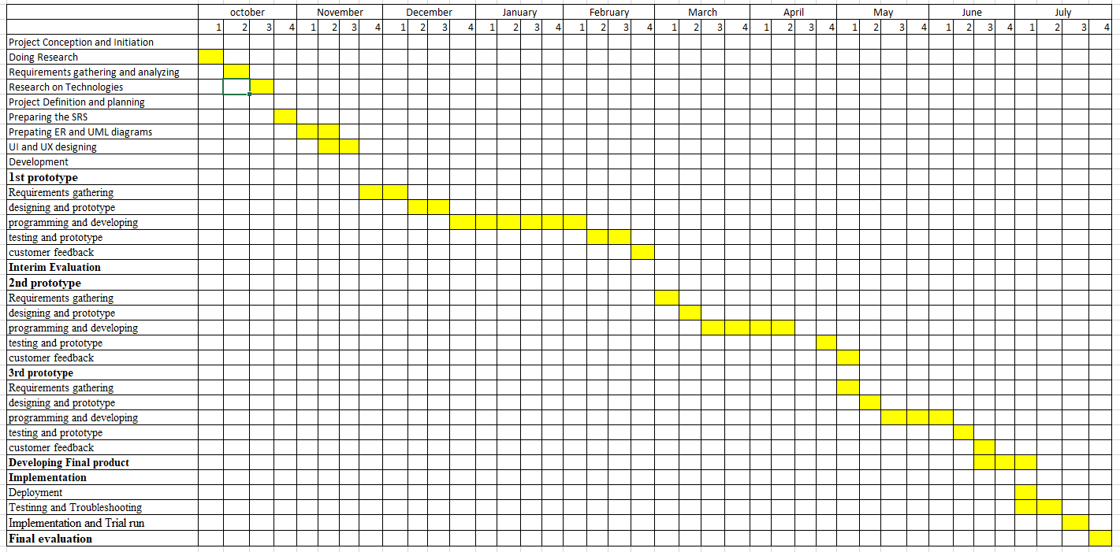

**6. Signatures of the Group Members**

|  |  |  |
| --- | --- | --- |
| **Index No** | **Name** | **Signature** |
| 205119P | Wijethilaka W.G.D.C.D. |  |
| 185067A | Rosni H.F. |  |
| 205063L | Madhushika D.S. |  |
| 205016X | De Silva R.M.M. |  |
| 205091U | Sadhoon M.I.A. |  |

**7. Supervisors’ declaration**

I hereby declare that I have checked this project, and, in my opinion, this project is adequate in terms of scope and quality

1. Name of Supervisor: Dr. S.C. Premaratne

Designation: Head, Department of Information Technology.

Date: 2022/11/01

Signature: 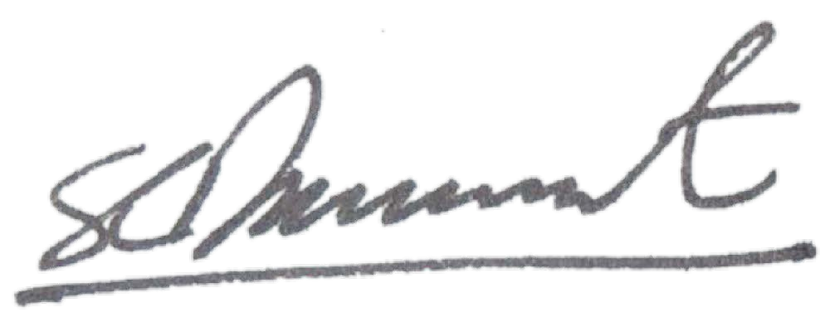

Any further comments:

1. Name of Supervisor: Mrs. M.B. Mufitha

Designation: Student Counselor.

Date:

Signature:

Any further comments: